

**Syntactic and Semantic Interoperability in Fast Health Interoperable Resource (FHIR)**

*DISSERTATION SUBMITTED TOWARDS THE PARTIAL FULFILLMENT OF THE REQUIREMENTS FOR THE AWARD OF A DEGREE IN*

**BACHELOR OF TECHNOLOGY**

**IN**

**COMPUTER ENGINEERING**

*BY*

|  |  |
| --- | --- |
| Harsh Kumar | 2K14/CO/041 |
| Krittika Pal | 2K14/CO/052 |
|  |  |

*UNDER THE ESTEEMED GUIDANCE OF*

**Ms Divyashikha Sethia**

**DEPARTMENT OF COMPUTER ENGINEERING**

**DELHI TECHNOLOGICAL UNIVERSITY**

**DELHI, INDIA**

**2016**

**CERTIFICATE**

This is to certify that the dissertation titled “***Syntactic and Semantic Interoperability in Fast Health Interoperable Resource(FHIR)***”, submitted by **Harsh Kumar** and **Krittika Pal** towards the partial fulfilment of the requirement for the degree in Bachelor of Computer Engineering, is a bonafide record of their work carried out under the supervision and guidance of Ms Divyashikha Sethia.

**Ms. Divyashikha Sethia**

Assistant Professor

Computer Engineering Department

Delhi Technological University

Delhi

**DECLARATION**

We, **Harsh Kumar (2K14/CO/041) and Krittika Pal (2K14/CO/052)** hereby declare that the work which is being presented in this report titled ***“Syntactic and Semantic Interoperability in Fast Health Interoperable Resource(FHIR)”*** in the partial fulfillment of Minor Project-1 for the award of the Degree of Bachelor of Technology in Computer Engineering, submitted in the Computer Engineering Department of DELHI TECHNOLOGICAL UNIVERSITY is an authentic record of the literature review carried out during the period from August 2016 to November 2016, under the guidance of our faculty advisor Ms. Divyashikha Sethia.

The matter presented in this report has not been submitted in any other University/Institute for the award of any diploma or degree.

Harsh Kumar

2K14/CO/041

Krittika Pal

2K14/CO/052

**ACKNOWLEDGEMENT**

We would like to express our gratitude and appreciation to all those who gave us the support to complete this project.

A special thanks to our mentor and project guide, Ms Divyashikha Sethia, whose help, stimulating suggestions and encouragement, helped us to make our ideas come into reality.

I would also like to express our gratitude towards our HoD, Dr O P Verma, for helping in research and providing the devices for student projects.

The crucial role of the staff of Computer & Software Engineering is also acknowledged with much appreciation, which helped us throughout the process of the development of this project by giving appropriate suggestions and assistance.

Also, I am obliged to mention the support provided by our parents and our peer group.

Also, I would like to appreciate the contribution and help provided to us by the seniors and staff working in LANS Lab.

**Table of Contents**

**Acknowledgement**

**1. ABSTRACT**

**2. INTRODUCTION**

**2.1 BACKGROUND:**

**2.1.1 Why do we need standards?**

**2.1.2 Electronic Health record**

**2.1.3 Comparison with Paper based records**

**2.2 Motivation**

**2.3 Problem Statement**

**3. Literature Review**

**3.1 What is HL7?**

**3.2 Who uses HL7?**

**3.3 Philosophy of HL7 versions**

**3.3.1 HL7 version 2**

**3.3.2 HL7 Version3**

**3.3.3 Comparison between v2 and v3**

**4. FHIR**

**4.1Comparison to existing standards**

**4.1.1 HL7 v2**

**4.1.2 HL7 v3**

**5. FHIR Architecture and Implementation**

**5.1 Embrace web technologies**

**5.2 Human readability**

**5.3 Paradigms for packaging the payload**

**5.4 HAPI FHIR Servers**

**5.5 FHIR Resources**

**5.6 Sample FHIR resource example**

**6 Testing and Implementation**

**6.1 Syntactic Interoperability**

**6.2 Semantic Interoperability**

**6.3 Specific Example EEG data mapping with plots, include python code snippet too**

**7. Future Work and Conclusion**

**REFRENCES:**

**Appendix A: Querying the Server**

**LIST OF FIGURES:**

Figure 1: Electronic Health Data-Pre EHR 10

Figure 2: Electronic Health Record 11

Figure 3: Approximate real-world usage of HL7 messaging standards. The vast majority of HL7 messaging is done using messages that approximate HL7 2.3 or HL7 2.3.1. Newer releases of HL7 (2.5, 3.0, and soon 2.6) represent a very small portion of real-world interface 13

Figure 4: Sample HL7 v2 data [23] 15

Figure 5:Sample HL7 v3 data[24] 16

Figure 6: FHIR INTRODUCTION 18

Figure 7: Comparison between v2 and FHIR 20

Figure 8: Comparison between v3 and FHIR 20

Figure 9: FHIR Architecture [26]. 22

Figure 10: FHIR Resources 23

Figure 11: EEG Observation data mapping of 10 sample records on FHIR server . 26

Figure 12: Mapping Observation Data 26

**ABSTRACT**

This project explores the standardization of electronic health records and tries to explore various resources to determine the most robust, scalable and simplified standard for deploying digitisation of health records. We examined the potential of the new Health Level 7 (HL7) standard Fast Healthcare Interoperability Resources(FHIR), a standard to help achieve healthcare systems interoperability. With comprehensive testing of FHIR and complete exploration of its features (especially for mental health records). This study provides a chronicle of the evolution of the HL7 messaging standards(comparison with version2 version 3), an introduction to HL7 FHIR, deployment of a fully functional FHIR server and exploring the behavioural health profile in FHIR. With this study, we also explored the major potential that FHIR as a standard can provide in fields of a unification of global healthcare system and data mining for further technological exploration.

**2. INTRODUCTION**

**2.1 BACKGROUND:**

**2.1.1 Why do we need standards?**

Clinical care increasingly requires healthcare professionals to access patient record information that may be distributed across multiple sites, held in a variety of paper and electronic formats, and represented as mixtures of narrative, structured, coded and multimedia entries[1][2]. A longitudinal person-centred electronic health record (EHR)[3] is a much anticipated solution to this problem, but the challenge of providing clinicians of any profession or speciality with an integrated and relevant view of the complete health and health care history of each patient under their care has so far proved difficult to meet[4]. From an academic vision in the late 1980’s the Electronic Health Record (EHR) has evolved to become centre-stage in the national health informatics strategies of most countries internationally[5]. International research over the past fifteen years has highlighted the clinical, ethical and technical requirements that need to be met in order to effect this transition[6]. There is a need for interoperability standards meeting these requirements that can permit clinical computer systems to share health record data whilst preserving faithfully the clinical meaning of the individual authored contributions within it [7]. Patients nowadays also require access to their own EHR to an extent that permits them to play an active role in their health management. These requirements are becoming more urgent as the focus of health care delivery shifts progressively from specialist centres to community settings and to the patient’s personal environment [8].

**2.1.2 Electronic Health record**

The EHR is a longitudinal electronic record of patient health information generated by one or more encounters in any care delivery setting. Included in this information are patient demographics, progress notes, problems, medications, vital signs, past medical history, immunizations, laboratory data and radiology reports.[9] The EHR automates and streamlines the clinician's workflow. The EHR has the ability to generate a complete record of a clinical patient encounter - as well as supporting other care-related activities directly or indirectly via interface - including evidence-based decision support, quality management, and outcomes reporting.

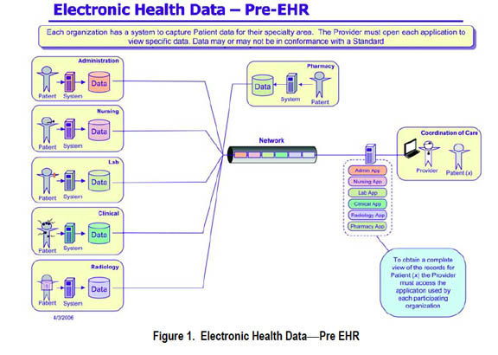

Figure 1: Electronic Health Data-Pre EHR

**2.1.3 Comparison with Paper based records**

One VA study estimates its electronic medical record system may improve overall efficiency by 6% per year [10]. A 2014 survey of the American College of Physicians member sample, however, found that family practice physicians spent 48 minutes more per day when using EMRs. 90% reported that at least 1 data management function was slower after EMRs were adopted, and 64% reported that note writing took longer. A third (34%) reported that it took longer to find and review medical record data, and 32% reported that it was slower to read other clinicians' notes [11].

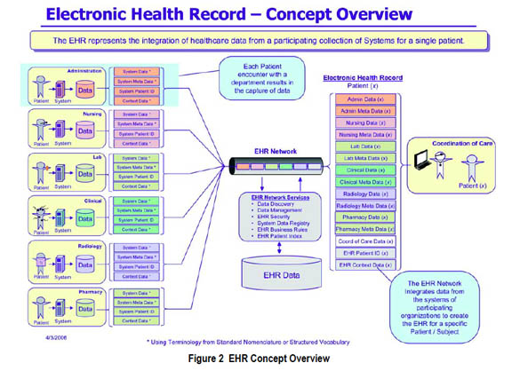

Figure 2: Electronic Health Record

**2.2 Motivation**

Health records when stored and maintained in a proper format can lead to a varied amount of benefits. The electronic interoperable health records can help in diagnostics of patients going through the same ailment that has been cured before. The mapping of the behavioural health data can, not only help doctors in proper diagnostic of complex behavioural disease, but also for the patients who desperately search for a way out of their situation. The presence of an EHR system, that is compatible across hospitals, labs, chemists, crosses geographical boundaries, will revolutionize the way health system works in India. The driving factor behind this study was to explore the already existing standards, compare and contrast them with the latest one and prepare an interface to electronically map data into such a standard.

**2.3 Problem Statement**

The main objective of this study was to provide a platform for end to end connectivity between a doctor, lab technician and or a patient. We explored in depth the most recent HealthCare Standard for such end to end connectivity. RESTful API calls were made to the locally hosted server to host the data, query the data and process the data, the way a doctor or physician would require.

The health data that we used was collected from epileptic patients, and was available online, the data was mapped into the standard FHIR format and put up on local hosted FHIR server.

**3. Literature Review**

**3.1 What is HL7?**

In extremely general terms, HL7 is a messaging standard that enables clinical applications to exchange data. In today’s world of e-mail, FTP, Bluetooth, and high-speed downloads, that may seem passé, if not unremarkable. In the healthcare “every user and setting is unique” world, however, that type of data exchange can be challenging.

In 1987, in an attempt to begin solving this problem, an international community of healthcare subject matter experts and information scientists collaborated to create the HL7 standard for the exchange, management, and integration of electronic healthcare information. [12]

Today, HL7 is a standards developing organization accredited by the American National Standards Institute (ANSI) to author consensus-based standards representing a broad view from healthcare system stakeholders [13]. From a practical standpoint, the HL7 committee has compiled a collection of message formats and related clinical standards that loosely define an ideal presentation of clinical information. Together, the standards provide a framework in which data may be exchanged [14].

The name Health Level 7 symbolizes the seven-layer International Standards Organization (ISO) Communications Model:

* Physical: Connects the entity to the transmission media
* Data Link: Provides error control between adjacent nodes
* Network: Routes the information in the network
* Transport: Provides end-to-end communication control
* Session: Handles problems that are not communication issues
* Presentation: Converts the information
* Application: Provides different services to the applications

**3.2 Who uses HL7?**

In order to set the context for both HL7 V2 and V3, it is critical to understand the user types for the messaging standards and how each user type influences both the development and use of the standard. Users can be divided into three segments [15]:

1. Clinical interface specialists who are tasked with moving clinical data, creating tools to move such data, or creating clinical applications that need to share or exchange data with other systems. These users are responsible for moving clinical data between applications or between healthcare providers.

2. Government or other politically homogeneous entities that are looking to the future of sharing data across multiple entities or in future data movement – generally, few legacy systems are present. Often these users are looking to move clinical data in a new area not covered by current interfaces and have the ability to adopt or mandate a messaging standard.

3. Medical informatics who works within the field of health informatics, which is the study of the logic of healthcare and how clinical knowledge, is created. These users seek to create or adopt a clinical ontology – a sort of hierarchical structure of healthcare knowledge (a data model), terminology (a vocabulary), and workflow (how things get done). An informatics is interested in the theoretical representation, semantic interoperability, and extensive modelling of the acts and actors of healthcare.

**3.3 Philosophy of HL7 versions**

**HL7 version 2**

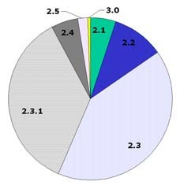

Figure : Approximate real-world usage of HL7 messaging standards. The vast majority of HL7 messaging is done using messages that approximate HL7 2.3 or HL7 2.3.1. Newer releases of HL7 (2.5, 3.0, and soon 2.6) represent a very small portion of real-world interface[16]

* It is fair to say that early releases of HL7 (v2.1 and v2.2) were vague and under documented when compared to later releases. In early v2, little was formally specified for a number of reasons:
* The community needed more users and vendors to adopt the standard
* The more flexible and vague the standard, the easier it would be for applications to adopt it
  + If the standard was too rigid, it would be easy to dismiss as “unworkable” because every healthcare entity and application is “special”
* Early versions of HL7 only needed to specify about 80 per cent of the interface in the framework
* The tipping point for HL7 V2 acceptance came in 1998. About this time, enough vendors and healthcare providers had implemented HL7 that it was more advantageous for newly connected applications to take advantage of the 80 per cent standard interface. Building a 100 per cent custom interface was no longer justifiable or needed.
* The V2 standard grew over time as it became more defined and covered more areas. The first usable version was 2.1 (released in 1990) with minor additions in 2.2 (1994) and ultimately 2.3 (1997) and 2.3.1 (1999) [17].
* The exact version of HL7 used by an application is not critical since the v2 versions are mostly compatible with one another. Said another way, HL7’s V2 philosophy is that newer versions of HL7 V2 should be backwards compatible with older versions of 2.X.
* As data elements and messages are added to new V2 releases, they are marked as optional elements. The backwards compatibility means that, in general, a newer application can process a message from an older application and an older application can process a newer message. This is a very attractive idea but can be challenging to implement [18].
  + 1. **HL7 Version3**

As indicated, HL7 v2 is a market success, yet it continues to be refined. Many HL7 community members volunteer to enhance HL7 messaging and improve the methods used to define it. Most agree that the primary challenges with HL7 v2 are [19]:

* **Lack of consistent application data model which is only implied in the v2 standard** ─ the display/storage of data by a clinical application directly impacts what portions of HL7 it can successfully implement.
* **Lack of formal methodologies** **to model data elements and messages -** This causes inconsistencies within the standard and difficulties understanding how message elements relate to each other.
* **Lack of well-defined application and user roles** ─ Without defined roles, which portions of HL7 are supported is a vendor choice causes large variation on which messages are used for a given set of clinical functions when two applications attempt to use the HL7 v2 standard.

In the late 1990s, a subset of the HL7 standards community decided to address these HL7 V2 challenges. The goals in creating the new HL7 V3 standard were [20]:

**Internationalization** — HL7 V3 needs to be able to be used by the worldwide HL7 organization while supporting the need for local variants.

**Consistent data model** — HL7 V3 needs to define the data model used by HL7 applications in order to have consistent data available for implementation.

**Precise standard** — HL7 V3 needs to take the information learned from all the HL7 v2 versions and create a standard that contains all the necessary data and is less vague and therefore less flexible.

**New standard** — as the community began to define HL7 V3, it decided that V3 would not be compatible with V2 for a number of reasons. Primarily, if V3 was backwards compatible with V2, the newer standard would be hamstrung with many legacy issues. Any attempt to retrofit an explicit data or application role model into V2 would be difficult and the antithesis of the vague v2 world. Finally, the standard needed breathing room so it could radically change in order to improve the quality of clinical interface.

From the outset, V3 promises to be a brave new world with “90 per cent or more” of the interface predefined. The primary value in the new standard will be an explicit data model, clear definitions, and more use cases that enable much less flexibility in individual message elements. The tighter standard promises “easier” interfaces for users [21].

* + 1. **Comparison between v2 and v3**

While the HL7 v2 standard was created mostly by clinical interface specialists, the v3 standard has been influenced strongly by work from volunteers representing the government and medical informatics users. This means that the level of formal modelling, complexity, and internal consistency is radically higher in V3 when compared to v2. Illustrated below is a sample of the difference in message formats between a v2 and v3 message [22].

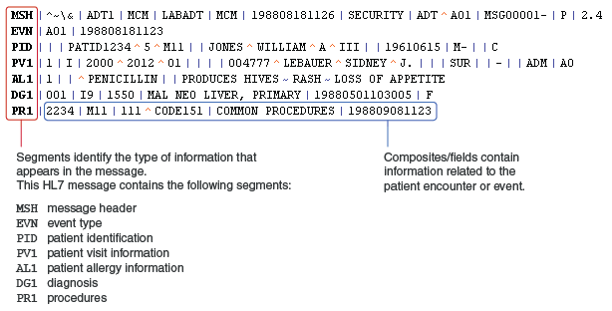

Figure 4: Sample HL7 v2 data [23]

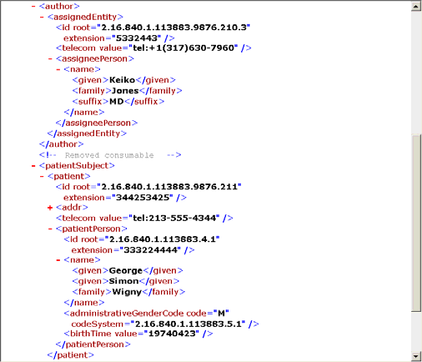

Figure 5:Sample HL7 v3 data[24]

|  |  |  |
| --- | --- | --- |
| STANDARD | ADVANTAGES | DISADVANTAGES |
| HL7 v2 | Reflects the complex “everyone is special” world of healthcare.  Much less expensive to build HL7 interfaces compared to custom interfaces  Provides 80 per cent of the interface and a framework to negotiate the remaining 20 per cent on an interface-by- interface basis  Historically built in an *ad hoc* way, allowing the most critical areas to be defined first  Generally provides compatibility between 2.X versions | Provides a “one size fits none” standard  “Loose and optional ridden” HL7 definitions  lead to discrepancies in  HL7 interfaces  Not inclusive of international needs  No compatibility with  HL7 V3  Defining a detailed list  of items to be discussed and negotiated before interfacing can occur is required  Application vendors do not support the latest and best-defined versions of HL7 |
| HL7 v3 | More of a "true standard” and less of a "framework for negotiation"  Model-based standard provides consistency across entire standard  Application roles well defined  Much less message optionality  Less expensive to build and maintain mid-to-long term interfaces  Many decades of effort over ten year period reflecting “best and brightest” thinking | For clinical interface specialists:  No compatibility with  HL7 V2  Adoption will be expensive and take time  Long adoption cycle, unless strong business case or regulatory requirement changes  Retraining and retooling necessary  Applications will have to support both V2 and V3 in the foreseeable future |
|  |  |  |
|  |  |  |

**Table 1: Comparison between HL7 v2 and v3**

**4. FHIR**

The introduction to FHIR states:

“These resources represent granular clinical concepts that can be exchanged in order to quickly and effectively solve problems in healthcare and related processes. The resources cover the basic elements of healthcare patients, admissions, diagnostic reports, medications, and problem lists, with their typical participants, and also support a range of richer and more complex clinical models. [25]”

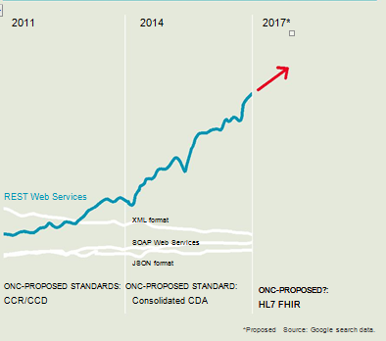

Figure 6: FHIR INTRODUCTION

FHIR is pronounced “Fire.” Let’s look at that name a little closer:

• **Fast** – it’s intended to be fast to develop and, more importantly, fast to implement.

• **Healthcare** – no surprise here, HL7 is about healthcare

• **Interoperability** – it’s focused on being a standard for interoperability (no different from most HL7 standards)

• **Resources.**

A FHIR Resource is analogous to an HL7 Version 2.x “Segment” or a Version 3 “CMET” (Common Message Element Types). FHIR Resources are:

• **Granular** – they are the smallest unit of operation, and a transaction scope of their own

• **Independent** – the content of a resource can be understood without reference to other resources • Simple – each resource is easy to understand and implement without needing tooling or infrastructure (though that can be used if desired)

• **RESTful** – resources are able to be used in a RESTful exchange context

• **Flexible** – resources can also be used in other contexts, such as messaging, document or SOA architectures, and moved in and out of RESTful paradigms as convenient

• **Extensible** – resources can be extended to cater for local requirements without impacting on interoperability

• **Web** **Enabled** – where possible or appropriate, open internet standards are used for data representation

• **Free** **for** **use** – the FHIR specification itself is open - anyone can implement FHIR or derive related specifications without any IP restrictions.

**4.1 Comparison to existing standards**

**4.1.1 HL7 v2**

HL7 v2 is a well-established standard that works well within institutions to connect applications. However, it is a legacy standard with unique syntaxes, custom tools, and a hefty learning curve for those entering the healthcare IT industry. The design of the standard is also limiting to modern devices and apps that are trying to leverage available patient data. Privacy and security are also difficult to implement. These limitations have become a barrier to patient engagement and making patient data available in the most convenient formats.

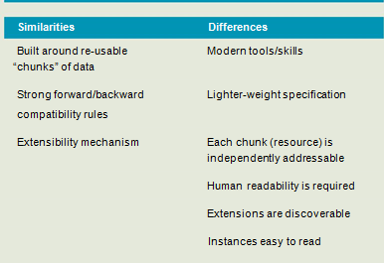

Figure 7: Comparison between v2 and FHIR

**4.1.2 HL7 v3**

HL7 v3 was meant to be the successor of HL7 v2. It leveraged modern standards technologies available at the time while being based on a reference model, but ended up being overly complex to implement with a steep learning curve. It also had no backwards compatibility with HL7 v2, which made switching to the new standard all the more complex given how embedded HL7 v2 is within the U.S. healthcare system.

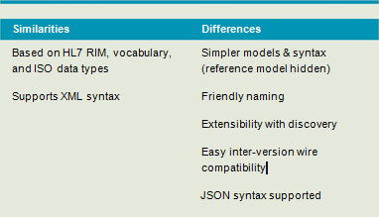

Figure 8: Comparison between v3 and FHIR

**5. FHIR Architecture and Implementation**

**5.1 Embrace web technologies**

The use of RESTful web services as an API has been on the rise over the last decade across all industries. RESTful web services are embraced by organizations such as Facebook, Twitter, and Amazon as their primary API. In addition, related technologies such as XML, JSON, and Oauth, are also common when dealing with encoding and authorization. These technologies have well supported tools and a large talent pool of IT resources. Thus, healthcare will not be locked in to unique industry standards, but can embrace what is used across all industries.

**5.2 Human readability**

The concept of human readability being the minimum level of interoperability was introduced with the CDA standard. The idea is that if none of the structured data is able to be imported into the receiving system, the data could be viewed in a standard web browser. HL7 FHIR continues with this concept to ensure that human readability will always be an option.

**5.3 Paradigms for packaging the payload**

HL7 FHIR plans to support four interoperability paradigms, which are distinct ways of utilizing FHIR to best accommodate varying workflows. The four paradigms and when they might be used are:

* REST Small, light-weight exchanges with low coupling between systems
* Messages Communicate multiple resources in a single exchange
* Documents Focus is on persistence when data spans multiple resources.

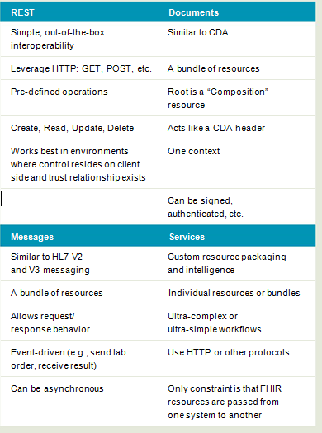

Figure 9: FHIR Architecture [26].

**5.4 HAPI FHIR Servers**

The HAPI FHIR library is an implementation of the [HL7 FHIR specification](http://hl7.org/implement/standards/fhir/) for Java. The FHIR specification is designed to be readable and implementable, and is filled with good information.

Part of the key to why FHIR is a good specification is the fact that its design is based on the design of other successful APIs (in particular, the FHIR designers often reference the High-rise API as a key influence in the design of the spec.)

**HAPI FHIR** is based on the same principle, but applied to the Java implementation.

The CLI tool can be used to start a local, fully functional FHIR server which you can use for testing. To start this server, simply issue the command **hapi-fhir-cli run-server**

Upload Example Resources (upload-examples)

The upload-examples command downloads the complete set of FHIR example resources from the HL7 website, and uploads them to a server of your choice. This can be useful to populate a server with test data.

To execute this command, uploading test resources to a local CLI server, issue the following: **hapi-fhir-cli upload-examples -t** [**http://localhost:8080/baseDstu2**](http://localhost:8080/baseDstu2) **[28]**

Note that this command may take a surprisingly long time to complete because of the large number of examples.

Upload Terminology

The HAPI FHIR JPA server has a terminology server, and has the ability to be populated with "external" code systems. These code systems are systems that contain large numbers of codes, so the codes are not stored directly inside the resource body.

HAPI has methods for uploading several popular code systems into its tables using the distribution files produced by the respective code systems. This is done using the **upload-terminology [29]** command.

**5.5 FHIR Resources**

Resources are small, logically discrete units of exchange. Resources define behaviour and meaning, have a known identity and location, are the smallest possible unit of transaction, and provide meaningful data that is of interest to healthcare. The plan is to limit resources to 100 to 150 in total. They are sometimes compared to an HL7 V2 segment. The resources can be extended and adapted to provide a more manageable solution to the healthcare demand for optionality and customization.

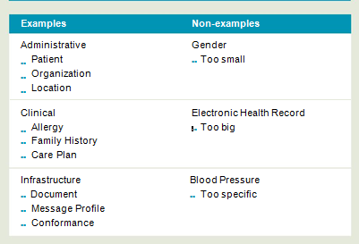

Figure 10: FHIR Resources

**5.6 Sample FHIR data(XML Format)**

**Observation Example**

<Observation xmlns=**"http://hl7.org/fhir"**>

<id value=**"observation-example-eeg.xml"**/>

<meta>

<versionId value=**"1"**/>

<lastUpdated value=**"2016-11-10T12:18:59.401+05:30"**/>

</meta>

<text>

<status value=**"generated"**/>

<div xmlns=**"http://www.w3.org/1999/xhtml"**>**Sept 17, 2012: Systolic Blood pressure 107 mmHg (normal)**</div>

</text>

<status value=**"final"**/>

<subject>

<reference value=**"Patient/p1"**/>

</subject>

<valueSampledData>

<origin>

<value value=**"0"**/>

<system value=**"http://unitsofmeasure.org"**/>

<code value=**"uV"**/>

</origin>

<period value=**"100"**/>

<factor value=**"2.5"**/>

<dimensions value=**"1"**/>

<data value=**"-4 -13 -18 -18 -18 -17 -16 -16 -16 -16 -16 -17 -18 -18 -1 -17 -16 -16 -16 -15 -13 -11 -10 -10 -9 -6 -4 -5 -5 -3 -2 -2 -1 1 2 7 8 9 10 11 12 13 15 17 19 21 23 25 27 29 30 30 31 34 37 40 43 45 4 46 46 46 46 47 49 51 53 55 57 59 60 59 58 58 58 57 56 56 56 57 57 5 53 50 47 45 74 51 38 33 31 2 25 21 16 14 15 13 9 7 4 1 -1 -3 -4 -6 -10 -12 -13 -12 -12 -17 -18 -18 -18 -19 -20 -21 -20 -20 -20 -20 -2 2 1 0 0 0 1 2 2 1 1 1 0 -1 0 1 1 1 1 2 E"**/>

</valueSampledData>

</Observation>

**6 Testing**

**6.1 Syntactic Interoperability**

     According to Wikipedia, If two or more systems are capable of communicating with each other, they exhibit syntactic interoperability when using specified [data for](https://en.wikipedia.org/wiki/File_format)mat, [communication protocols](https://en.wikipedia.org/wiki/Communication_protocol). With the advent of standards like xml, sql which are accepted for systems independent of software or architecture, achieving Syntactic interoperability has become simpler.

Since our data in FHIR are XML formatted structured data, Syntactic interoperability has been achieved.

**6.2  Semantic Interoperability**

FHIR is a highly standardized version with clear codes on how the data should be structured. it is has semantic interoperability. Because of structuring of data into resources and usage of rest API's. this is possible.  
  
In particular an implementation of REST follows four basic design principles of: i) using HTTP methods explicitly; ii) being stateless; iii) exposing directory-structure like URIs to resources; and iv) transferring XML or JSON or both as resource representations.

The practical advantages of RESTful architectures include light-weight interfaces that allow for faster transmission and processing of data structures, more suitable for mobile phones and tablet devices. RESTful interfaces also facilitate faster development cycles through their simpler structures.

Resources and their base operations very closely resemble the operation of a relational database-information structures are defined, operations on creating, updating, deleting and retrieving data is defined but the meaning of the data in an application is defined at a higher level.

<gender>

<coding>

<system value= **"http://hl7.org/fhir/v3/AdministrativeGender"**/>

<code value=**"F"**/>

</coding>

</gender>

Example of a Semantic Interoperable record.

**6.3 Specific Example -EEG data mapping with plots**

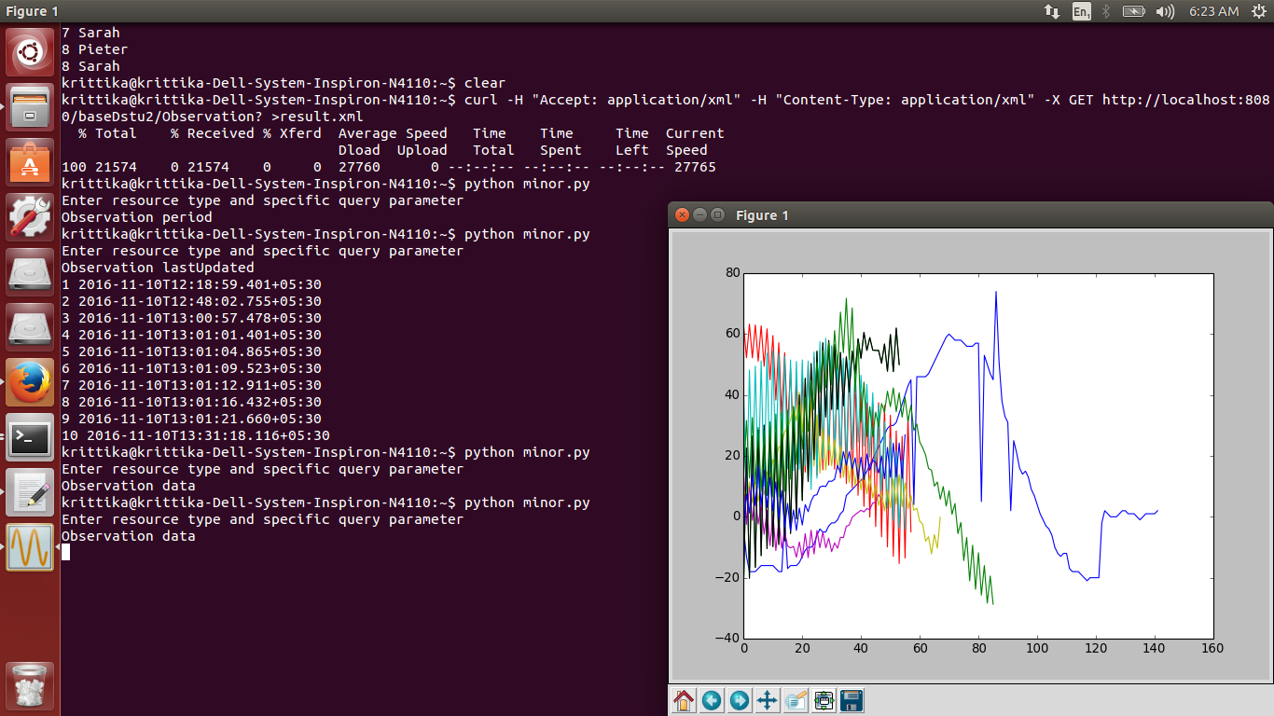

Figure 11: EEG Observation data mapping of 10 sample records on FHIR server .

**B. Mapping the particular observation fields, on the FHIR Server.**

The data present on the server was mapped to meaningful plots, so as to analyse and extract useful information related to a patient in a visual presentable and understandable manner.

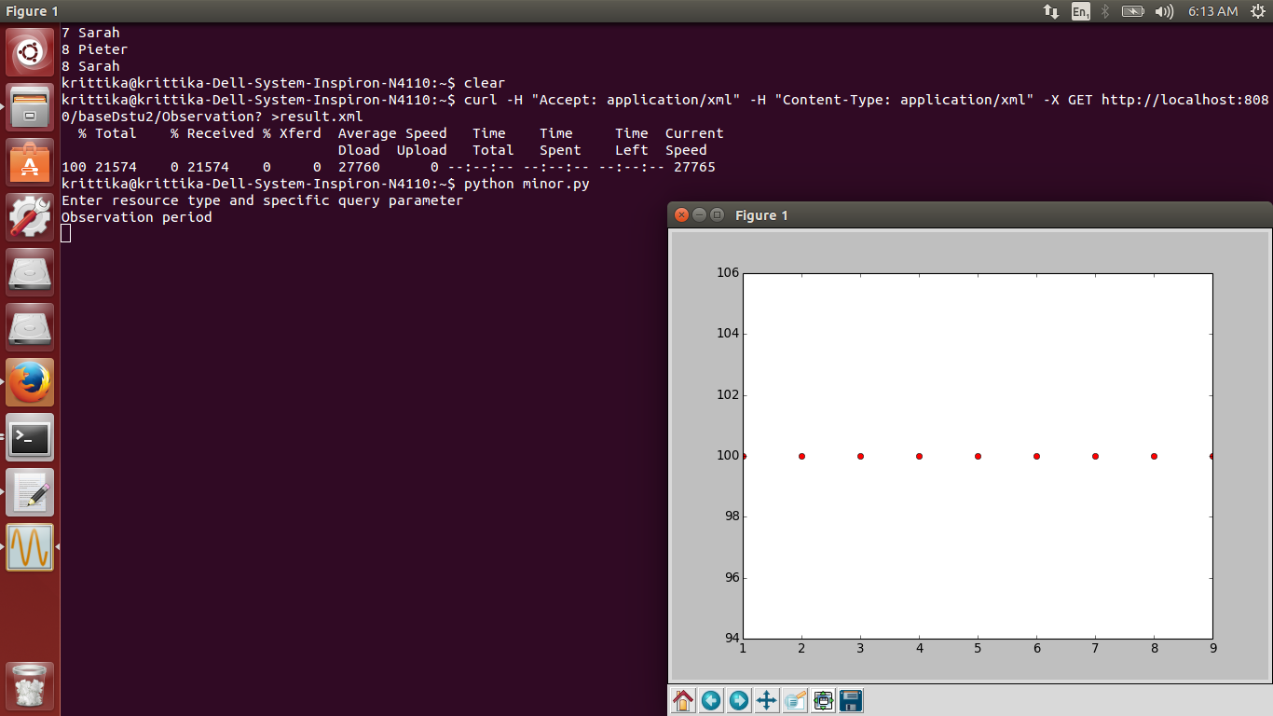

Figure 12: Mapping Observation Data

**7. Conclusion and Future Work**

The health industry is waiting to embrace a standard that offers something better, but given the embedded nature of HL7 V2, the transition will not happen overnight. FHIR tries to fill the gaps that exist with the standards in use today, as has been discussed in this paper. While the healthcare market will decide whether FHIR survives, coexists, or replaces other products, the modern technologies that it is basedon have already won over other industries. Additionally, other standards organization is jumping on board to support HL7 in the development of FHIR. One of those is IHE International, which plans to leverage FHIR across several profiles including:MHD (mobile XDS), PIXm/PDQm (patient identification), PCC (care coordination), and mACM (alerting).

FHIR technology represents a major opportunity to accelerate health care data interoperability across a wide range of currently disparate systems.

Because of the support of REST APIs , integrating FHIR into applications is much simpler, which supports the scalability. With options to query a server or multiple connected servers, which groups data because of semantic interoperability, running machine learning and using data mining techniques will pave way for further exploratory research , especially related to mental health records.

Ultimately, FHIR may become a critical technology driver for increasing health care quality, increasing patient access and use of health information and improving outcomes.

**REFRENCES**:

[1] Franz, Barbara, Andreas Schuler, and O. Kraus. "Applying FHIR in an Integrated Health Monitoring System." European Journal for Biomedical Informatics 11.2 (2015).

[2] Weatherall D, Greenwood B, Chee HL, et al." Science and Technology for Disease Control: Past, Present, and Future.” 2006

[3]Kaelber, David C., and David W. Bates. "Health information exchange and patient safety." Journal of biomedical informatics 40.6 (2007): S40-S45.

[4]Gliklich, Richard E., Nancy A. Dreyer, and Michelle B. Leavy. "Interfacing registries with electronic health records." (2014).

[5]Brian Ahier."FHIR and future of Interoperability" Available: http://www.healthcareitnews.com/news/fhir-and-future-interoperability,2015

[6]D. Bender and K. Sartipi, "HL7 FHIR: An Agile and RESTful approach to healthcare information exchange," Proceedings of the 26th IEEE International Symposium on Computer-Based Medical Systems, Porto, 2013, pp. 326-331.

[7]Kalra, Dipak. "Electronic health record standards." (2006): 136-144.

[8]FHIR Documentation and complete reference guide v1.0.2 Available: https://www.hl7.org/fhir/

[9]Kalra, Dipak, and David Ingram. "Electronic health records." Information technology solutions for healthcare. Springer London, 2006. 135-181.

[10]Atherton, Jim. "Development of the electronic health record." Virtual Mentor 13.3 (2011): 186.

[11] Wikipedia."What is a personal health record?". HealthIT.gov. Office of the National Coordinator for Health IT. Retrieved 2015-07-24.

[12]Technical Study. Available: https://www.par3emr.com/home/ehr

[13]HL7 FOR ELECTRONIC DATA EXCHANGE. http://www.itl.nist.gov/div897/ctg/messagemaker/slides/HL7_conf_MessageMaker.ppt

[14]The HL7 Evolution. Available: https://corepointhealth.com/wp-content/uploads/hl7-history-v2-v3.pdf

[15]Huff, Stanley M., et al. "Development of the logical observation identifier names and codes (LOINC) vocabulary." Journal of the American Medical Informatics Association 5.3 (1998): 276-292.

[16][17]The HL7 Evolution. Available: https://corepointhealth.com/wp-content/uploads/hl7-history-v2-v3.pdf

[18]Comparing HL7 v2 and v3. Available: http://www.slideshare.net/Corepoint/comparing-hl7-v3-with-hl7-v2

[19]HL7 Evolution. Available: https://corepointhealth.com/wp-content/uploads/hl7-history-v2-v3.pdf

[20]Comparing HL7 v2 and v3. Available: http://www.slideshare.net/Corepoint/comparing-hl7-v3-with-hl7-v2

[21]HL7 Standards Available: http://www.hl7.org/implement/standards/index.cfm?ref=nav

[22]HL7 Evolution and Standard. Available: https://www.scribd.com/document/125151772/hl7-v2-v3-evolution

[23]Figure. Available http://image.slidesharecdn.com/hl7v2messagingconformancejan2011-110303095217-phpapp02/95/hl7-v2-messaging-conformance-jan-2011-15-728.jpg?cb=1299146151

[24]Figure. Available: https://i-msdn.sec.s-msft.com/dynimg/IC19014.gif

[25]Bowman, Sue E. "Coordination of SNOMED-CT and ICD-10: getting the most out of electronic health record systems." Coordination of SNOMED-CT and ICD-10: Getting the Most out of Electronic Health Record Systems/AHIMA, American Health Information Management Association (2005).

[26]White Paper. The complete White Paper: ‘What is HL7 FHIR?’2015 Available: https://corepointhealth.com/what-is-fhir

[27][28][29]Command Line Tool for HAPI FHIR Server. Available: http://hapifhir.io/doc_cli.html

**Dataset Source:**

The Bern-Barcelona EEG database

Epileptic Patients, EEG records, 10 patients, 750 Observations(available for public use)

**Available:** http://ntsa.upf.edu/downloads/andrzejak-rg-schindler-k-rummel-c-2012-nonrandomness-nonlinear-dependence-and

**APPENDIX A:**

**Querying the Server**

Queryingon Name of Patient:

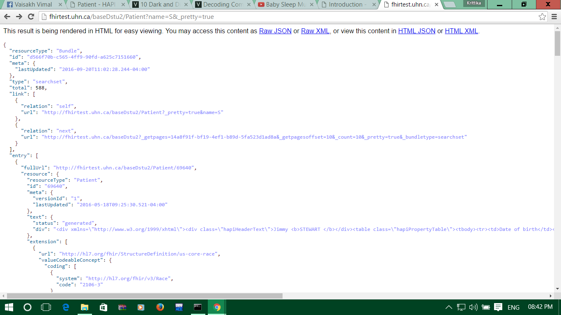

Querying a Patient based on geographic location:

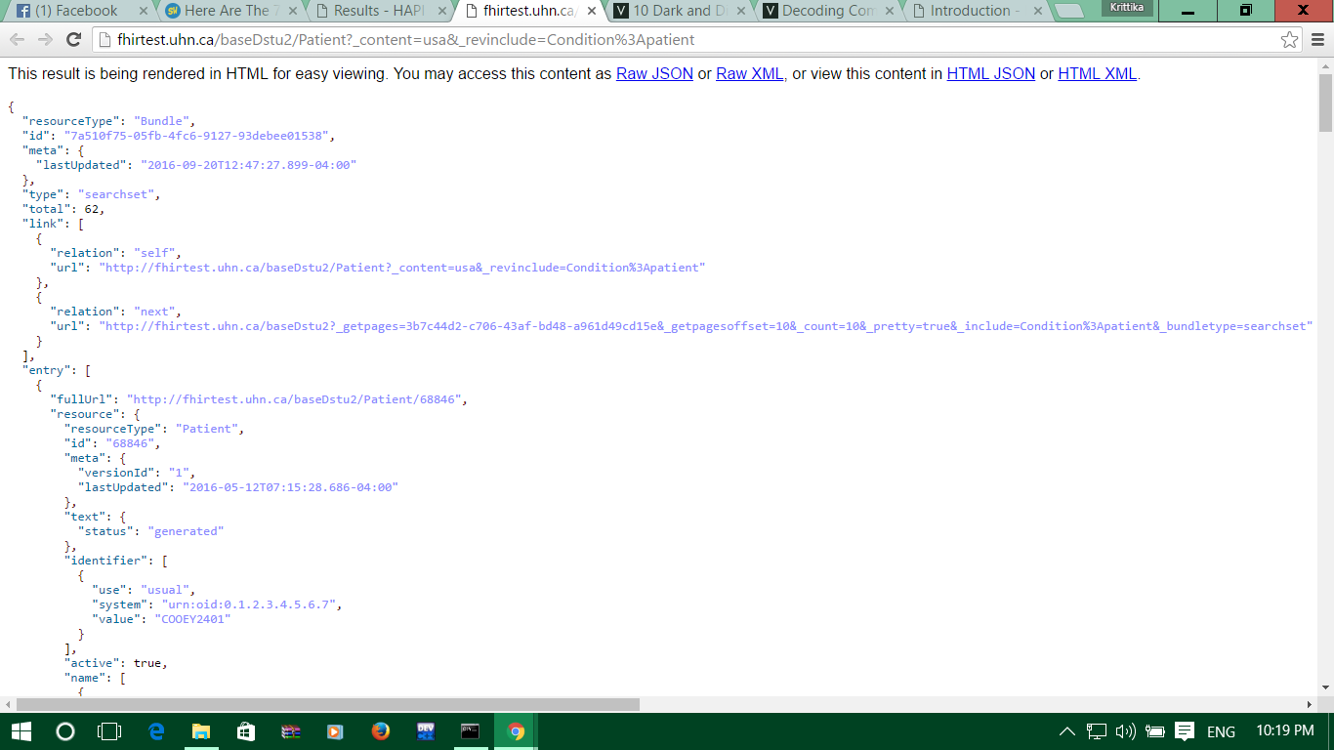

UNION And LIKE Operation Queries

